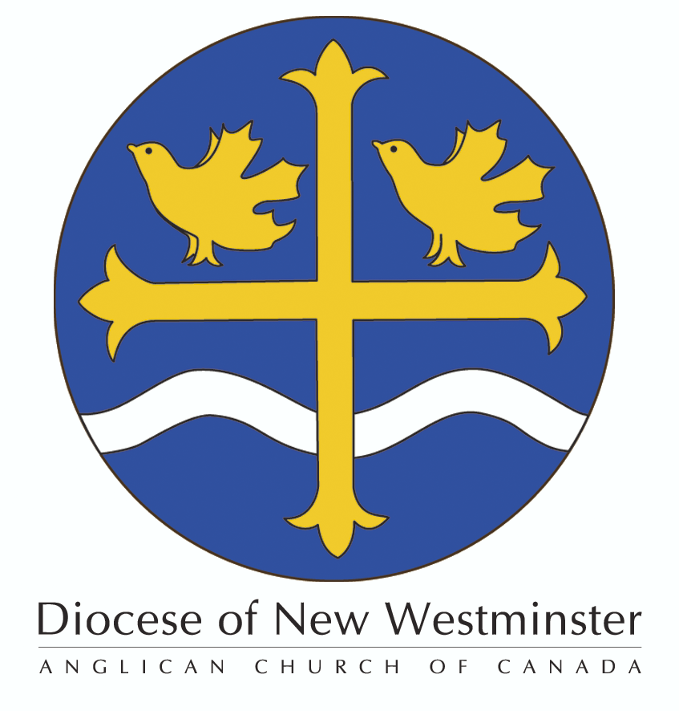

The Order of the
Diocese of New Westminster

Nomination Form 2015

Please print clearly and do not change the layout of this form.
Only one person may be nominated per parish each calendar year.

NOMINEE
Please provide the Nominee’s FULL Name and indicate the name they normally use.

Title: (Circle preferred) Mr. / Ms / Mrs. / Dr.

Given Name(s):

Surname:

Name normally used: _________________________________________________________________

Parish: _____________________________________________________________________________

Nominee Contact Information:

Address:

Town/City: ______________________________________________ Postal Code:___________________

Home phone ( ) Work Phone: ( )

Mobile Phone: ( ) E-mail:
Acceptance of Nomination
I accept this nomination to the Order of the Diocese of New Westminster and consent to the publication of my photograph and and details of my service to my Parish and the Diocese should my nomination be approved.
Nominee’s Signature: _____________________________________ Date:_________________________
Biography: Please provide a brief biography of the Nominee. If more space is needed please use a separate sheet clearly indicating that it is a continuation of this section.

________________________________________________________________________________________________________________________________________________________________________________________________________________________________________________________________________________________________________________________________________________________________________________________________________________________________________________________________________________________________________________________________________________________________________________________________________________________________________________________________________________________________________________________________________________________________________________________________________________________________________________________________________________________________________________________________________________________________________

Citation: Please provide a narrative description (i.e. no bullet points) of this person’s service to the Parish and/or the Diocese, including the dates of service (please see the eligibility requirements on the nomination information document). If more space is needed please use a separate sheet clearly indicating that it is a continuation of this section.

This information will be recorded in the permanent record of the Order and will form the basis for the citation read at the Investiture Service.

______________________________________________________________________________________________________________________________________________________________________________________________________________________________________________________________________________________________________________________________________________________________________________________________________________________________________________________________________________________________________________________________

Parish Support
Nominated by:
Name:
Signature:

Parish Approval:
This Nomination has been reviewed by the Rector. Following consultation between the Rector and the Wardens of this parish we are pleased to approve and support this Nomination for consideration by the Selection Committee.
Rector’s Name:
Rector’s Signature:
Warden’s Name:
Warden’s Signature:
Warden’s Name:
Warden’s Signature:
(Please add additional names and signatures as needed to ensure that all parish wardens have signed this form.)
Date:
Nomination Deadline, Photo and Fee
The deadline for nominations is April 30, 2015.
This Nomination Form must be accompanied by a photo (3” x 5” preferred) of the Nominee and a $25 processing fee payable to the “Diocese of New Westminster” (please note in the memo line of the cheque “ODNW”). The Nomination Form, photo, and cheque must be received in the Bishop’s Office by April 30th, 2015.
Please send them to:
The Diocese of New Westminster
Attention: Bill Siksay
#580 – 401 West Georgia Street,
Vancouver, BC V6B 5A1
Fax: 604-684-7017
e-mail: bsiksay@vancouver.anglican.ca
If you have any questions regarding the Order of the Diocese of New Westminster please call Bill Siksay at 604-684-6306 ext. 228.
To be completed by the Synod Office
Date Rec’d: Fee: Photo: Ack:
Comments of Selection Committee:
Selection Committee Member Signature
Approved: YES NO Notified on: ______________(attach letter to this form) Db:__________

