The Nota Bene Singers
A Cappella group

Director Philip Barker

Enjoy a mix of specially arranged songs, including ‘sacred, secular and silly,’ performed by the 2017 winners of the Chilliwack Music and Dance Festival Lange Cup Trophy for adult choirs

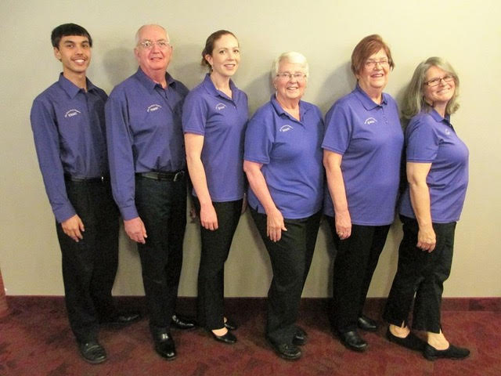

Saturday, September 16th, 2017
2.30pm
St John the Divine Historic Anglican Church
21299 River Road, Maple Ridge, V2X 2B1

Admission by Donation
to St John’s Church
$15.00 suggested; refreshments to follow concert

