2018 CALENDAR ORDER FORM

We are pleased to offer the Anglican-Lutheran Calendar for 2018.
The calendar has many improvements from last year’s calendar and many of the concerns have been addressed. We are very pleased that our Cathedral and the new Bell Tower are the main feature for the month of June.
The funds raised will assist the Anglican Church Women to continue with their many outreach programs. We appreciate your help with these commitments.

Make cheques payable to the ACW Diocese of New Westminster, noting your parish name on the cheque.

Name of Parish______________________________________________
Name of Contact Person______________________________________
Phone #____________________ email___________________________

Number of calendars ordered_______ x Cost $6.00 each = $_________
PLEASE have order and payment in before September 15, 2017 to
ACW Calendar Secretary, c/o ACW Place, Unit B, 7012 Merritt Avenue, Burnaby B. C. V5J 4R6
Orders can be mailed with the payment or phoned to the Calendar Secretary
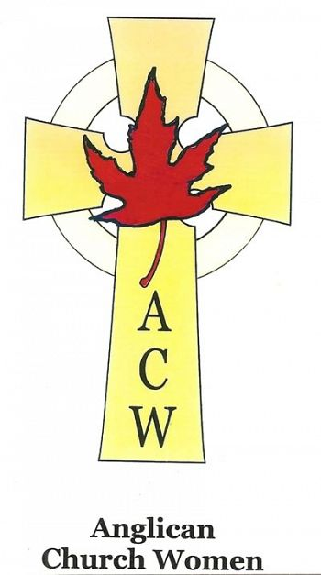
Marjory Henry at 604-434-6419
Many thanks for your support.
Anglican Church Women
Diocese of New Westminster

