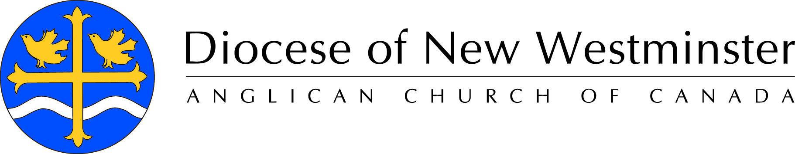
Biography
The Most Reverend Melissa Skelton
Archbishop, Diocese of New Westminster
Metropolitan, Ecclesiastical Province of British Columbia and Yukon

Elected Bishop on November 30th, 2013, Melissa Skelton was Consecrated and Installed as the 9th Bishop of the Diocese of New Westminster in Vancouver, British Columbia, Canada on St. David’s Day, March 1st, 2014. She is the first female diocesan bishop in the Diocese of New Westminster. In May 2018, she was elected Archbishop and Metropolitan of the Ecclesiastical Province of British Columbia and Yukon, becoming the first female Archbishop in the Anglican Church of Canada and the second in the Anglican Communion.

Archbishop Skelton was born in the United States. She was educated at the University of Georgia (BA, 1973), The University of Chicago (MBA, 1989) and at the Protestant Episcopal Seminary, Alexandria, Virginia (Master of Divinity, 1990). She was ordained a priest in The Episcopal Church in 1993.

Some highlights of Archbishop Skelton's career since 1991 include:

• Director for the Diocesan School for Leadership and the College for Congregational Development - Diocese of New Westminster, Vancouver, BC, 2011 – currently
• Canon for Congregational Development and Leadership – Diocese of Olympia, Seattle, WA, 2008-February 15th, 2014.
• Rector - St. Paul’s Episcopal Church, Seattle, WA, 2005-February 15th, 2014
• Rector - Trinity Church, Castine, ME, 2002-2005
• Congregational Development Consultant – Diocese of Maine, 2002 - 2004
• Vice President of Brand and Systems Development - Tom’s of Maine 1997-2001
• Vice President for Administration – The General Theological Seminary, New York
• Associate Priest - St. Andrew’s Episcopal Church, Trenton, NJ, 1994-96
• Priest Associate - Trinity Wall Street, Manhattan, 1993-94
• Brand Manager - Procter & Gamble, Cincinnati, 1992-93

Archbishop Skelton leads an active and busy life in ministry. Archbishop Melissa has three siblings: a brother in San Francisco and two sisters in Atlanta, GA. She also has an adult son, Evan who lives with his wife and two sons in Washington, DC.

