“One River, Ethics Matter” International Conference
Selkirk College, Castlegar, B.C. Canada

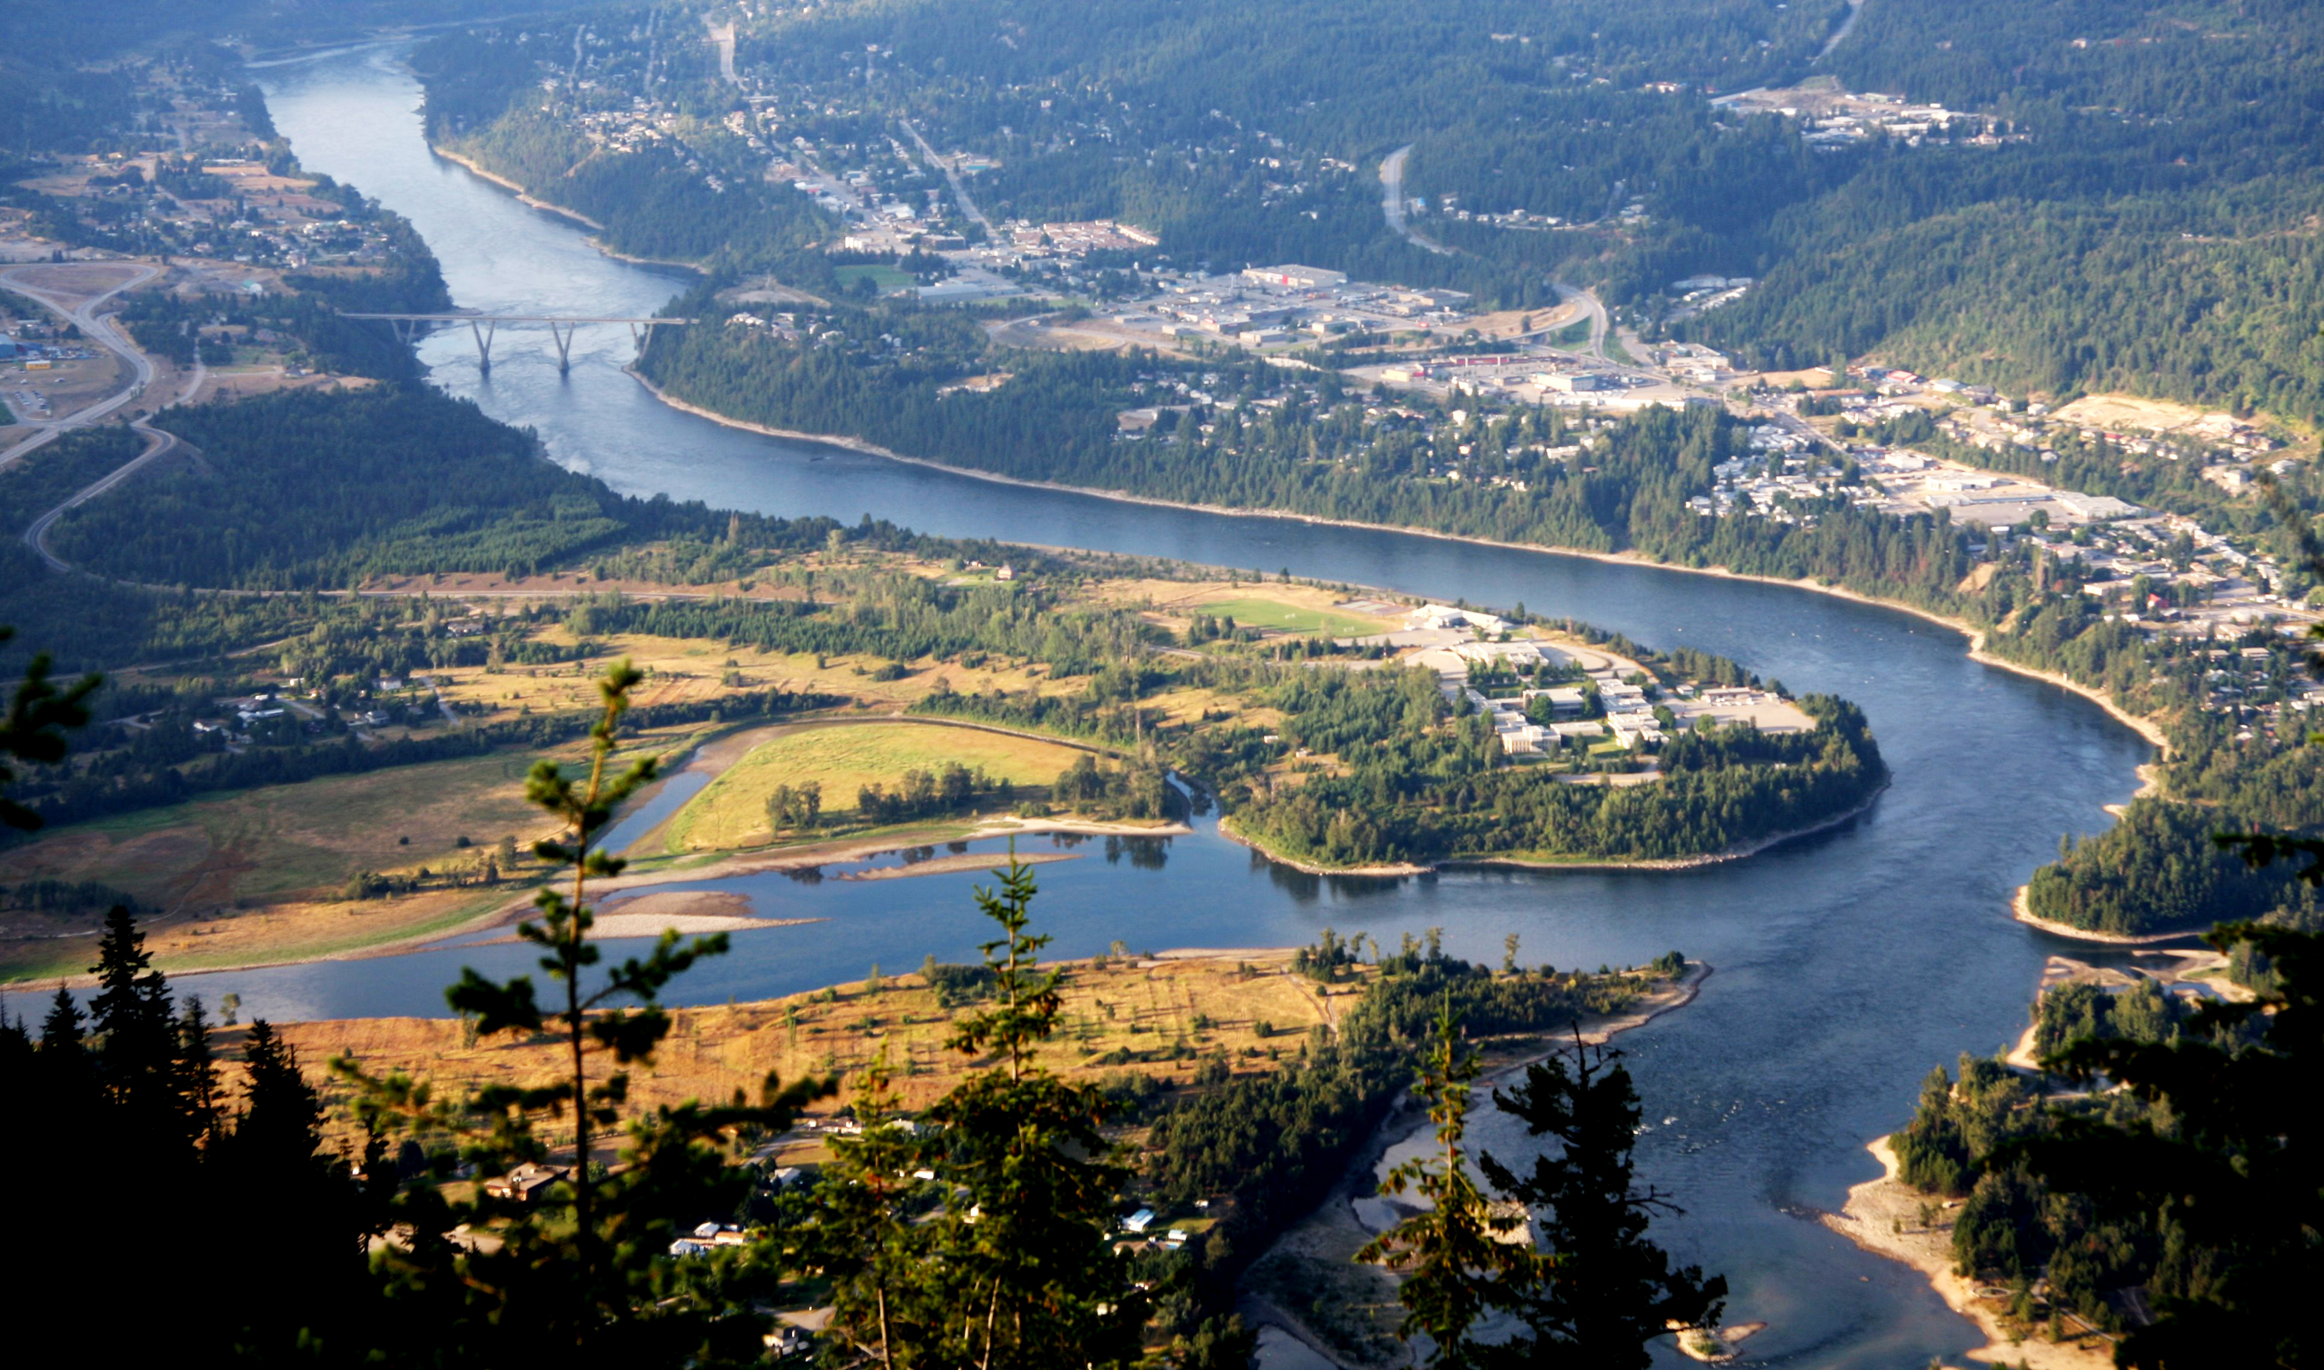
Special invitation to regional faith communities

On May 30 and 31, 2019, at Selkirk College, Castlegar, B.C., First Nation, tribal, academic, aquatic research, and religious leaders from the Upper Columbia River will lead a two-day conference on ethics and the past, present, and future of the Columbia River. Conference hosts are Selkirk College, Castlegar, and Spokane Community College, Spokane. The conference is free and open to the public.

This will be the sixth in a multi-year conference series based on the Columbia River Pastoral Letter (issued in 2001 by the Roman Catholic Bishops of the international watershed) and tools used by hospital ethics consultation services. The series is modeled on South Africa’s Truth and Reconciliation public dialogue in the wake of apartheid. The conference series is a initiative of the Ethics and Treaty Project with the goal of promoting principles of stewardship and justice in modernizing the Columbia River Treaty, which governs water and dam management on the Columbia River.

The Ethics and Treaty Project extends a special invitation to regional faith communities, since we know your traditions have a commitment to ethical decision making and the righting of injustice. A wide range of faith communities have supported the project's work through financial sponsorship of conferences and joint comment to government officials. Faith community leaders have been presenters at each of the conferences. Please share information about the conference with your community.
If you questions or if your faith community is able to support this vital work by providing a sponsorship of $100 or more, please contact conference coordinators Rev. W. Thomas Soeldner, John Osborn, or Jennie Barron.

The first day of the Castlegar conference will consist of field experiences and discussion with special attention to the voice of youth and the affect of Treaty negotiations on their future. The second day will bring together faith and indigenous leaders, educators, scientists, and writers on the past and future of the Columbia River with a focus on the upper reaches of the Columbia River and the confluence of history and ethics. It will examine the moral dimensions of the dam-building era with a focus on tribes (U.S.) and First Nations (Canada), rivers and life that depends on rivers, and compelling need to add Ecosystem-based Function as a primary purpose of the Columbia River Treaty during Treaty negotiations.

Five prior “One River. Ethics Matter” conferences were held in Spokane (2014), Portland (2015), Boise (2016), Revelstoke (2017), and Missoula (2018).

Conference webpage for more information and to RSVP.

