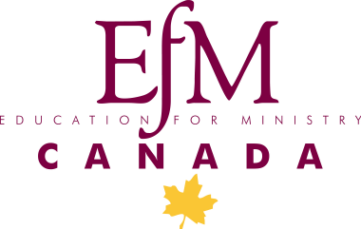

The EFM groups at Christ Church Cathedral are
starting a new year in
January.

New participants are welcome!

Education for Ministry is a program of theological education by extension for lay people. There are four years of study, but participants commit for one year at a time, meeting in small groups with a trained mentor. The program combines academic study with integrative components to help participants take what they learn about Scripture, church history, theology and ethics into their own lives and hearts, supporting them in living out a vibrant baptismal ministry in the church and in the world.
We meet Wednesday at the Cathedral 6:30 – 9:30 pm
We start on 8 January. Summer break is from the 2nd week of June
through Labour Day.
Please contact me if you are interested. I would be delighted to answer your questions and to tell you about the program.
Jim Berger, EfM Mentor
berger@zoology.ubc.ca

