2021 CALENDAR ORDER FORM
We are pleased to offer the Anglican Church Calendar for 2021.

The 2021 Canadian Anglican Church Calendar presents images and texts that tell us of what’s happening in, around and because of the Church. Each image invites us to return to it again and again and each text invites us to consider the witness of our ancestors.

The funds raised will assist the Anglican Church Women to continue with their many outreach programs. We appreciate your help with these commitments.
Make cheques payable to the ACW Diocese of New Westminster, noting your parish name on the cheque.

Name of Parish______________________________________________
Name of Contact Person______________________________________
Phone #____________________ email___________________________

Number of calendars ordered_______ x Cost $6.00 each = $_________
PLEASE have order and payment in before September 4, 2020 to
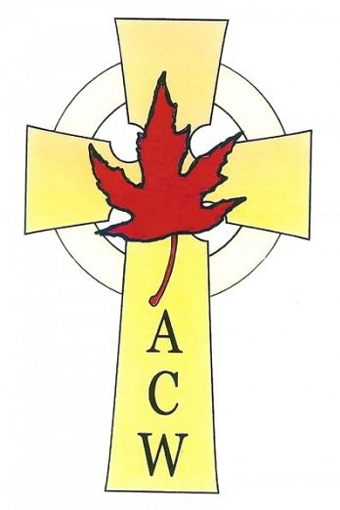
ACW Calendar Secretary, c/o ACW Place, Unit B, 7012 Merritt Avenue, Burnaby B. C. V5J 4R6

Many Thanks for your support

Anglican Church Women

Diocese of New Westminster
Orders can be mailed with the payment to our NEW secure mail box or emailed to the Calendar Secretary: sylviaanneenga@gmail.com.

