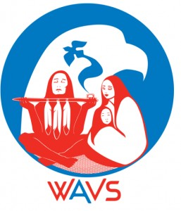

The purpose of this letter is to invite you to participate in the Warriors Against Violence Society silent auction fundraiser. We will be hosting our annual fundraiser online again this year, and we hope to generate interest and excitement through the participation of businesses such as yours!

Warriors Against Violence Society (WAVS) is a non-profit organization that has been serving the community since 1998 and is committed to addressing all forms of domestic violence in Indigenous communities. WAVS offers support to men, women and families through group work, education, and an opportunity to reconnect to traditional values and practices. WAVS creates a community environment that supports and rehabilitates through the reclamation of the traditional values of honor, respect, and equality. Men and women have not only benefited from WAVS' programming and referred friends and family but have also maintained a connection with the organization long after their participation.

During the coronavirus crisis, WAVS has continued to provide services through one-on-one, telephone counselling, and virtual group meetings for men and women. The global pandemic has affected all communities but has had a particularly devastating impact on Indigenous communities that has spurred demand for the unique services that WAVS provides.

As a grassroots community-based non-profit, WAVs is funded entirely through grants and through generous contributions from the community and local business partners such as yours. This year, we are hoping to raise funds through our silent auction online to continue to provide services and supports that directly benefit the well-being of the Indigenous community in the lower mainland. Our auction will go live on Facebook on December 1st. If you are interested in contributing, we ask that you get in touch by November 30th.

Here are some ways that you can help:

- Consider donating to our silent auction - all items and services are welcomed!
- Participate in the auction by bidding on some items
- Like and Share our Facebook page and related auction posts to help us get the word out!

We thank you for your consideration and appreciate any support that you can offer!

Sincerely,
The Warriors Against Violence Society

T O M A K E A D O N A T I O N P L E A S E C O N T A C T U S
Phone: 6 0 4 - 2 5 5 - 3 2 4 0
Email: warriors@kiwassa.net

W W W . W A V - B C . C O M

